poplib receive mail

First of all, introduce some interfaces of poplib to log in and download emails

We need some constants as above to specify the login mailbox and pop, smtp server and port. We call poplib's POP3_SSL interface to log in to the mailbox.

When logging in to the mailbox, it is natural that we need to provide a user name and password, as shown in the above code,

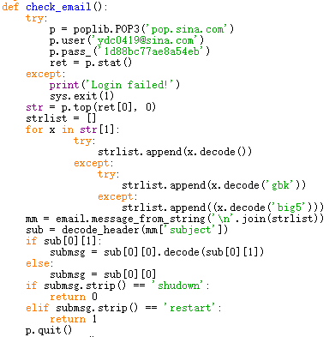

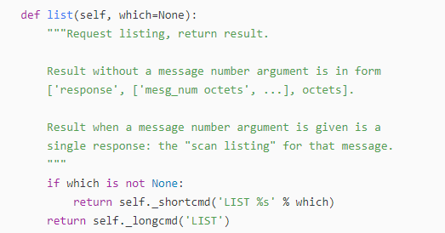

We see the comment of the list method. Its Chinese meaning is that the list method has a replacement parameter, and its replacement does not. When the caller has no notification parameter, the method will list all the mail information, and its return form is [response, ['msg_number, octets',...], octets], where response is the response result, msg_number is the mail number, and octets is an 8-bit byte unit.

The interface for poplib to get the email content is the retr method. It requires a parameter, which is the number of the mail to be obtained.

As we see the comment, we can know that the retr method can get all the contents of the email with the specified number, and its return form is [response, ['line',...], octets], it can be seen that the content of the email is stored in the returned In the second element of the tuple, its storage form is an array. Let's test what the array looks like.

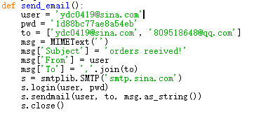

For example, our sample code is to find the subject and sender of the email, so we can write it as the code above.

Smtp send mail Like pop, before using smtp, you must provide it with some required constants:

The above is the code to log in to the mailbox using smtp, similar to pop.